Implementing a Secure Firmware Update Mechanism for IoT Devices
Research Project Report
Domain: Cyber Security & Ethical Hacking
Submitted to: Spinnaker Analytics
Submitted by: Telagamalla Srinivas
Submission Date: 23rd December 2025

Task 1: Architecture Design & Secure Boot Integration

1. Secure Bootloader Selection
For this project, MCUboot is selected as the secure bootloader. MCUboot is an open-source bootloader designed specifically for IoT and embedded devices. It provides firmware authentication, rollback protection, and recovery mechanisms.
Reasons for selection:
- Open-source and free to use
- Supports cryptographic firmware signature verification
- Designed for resource-constrained IoT devices
- Supports dual-slot firmware architecture
- Provides rollback protection and recovery support

2. System Architecture Overview
The secure firmware update system consists of an IoT device, firmware signing environment, secure update server, and management and monitoring components.
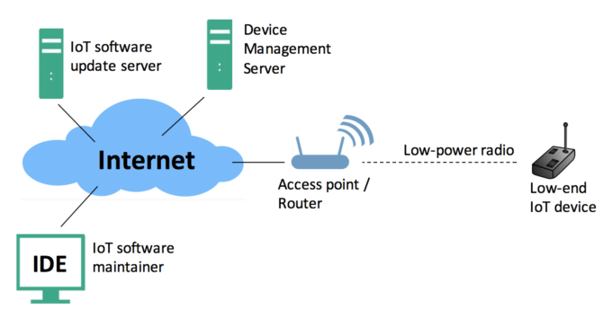
Figure 1: Secure Firmware Update System Architecture

3. Secure Boot Process Flow
On power-up, execution begins from the Boot ROM and control is transferred to MCUboot. MCUboot verifies the firmware digital signature using a stored public key. Valid firmware is executed, while invalid firmware triggers recovery mode.

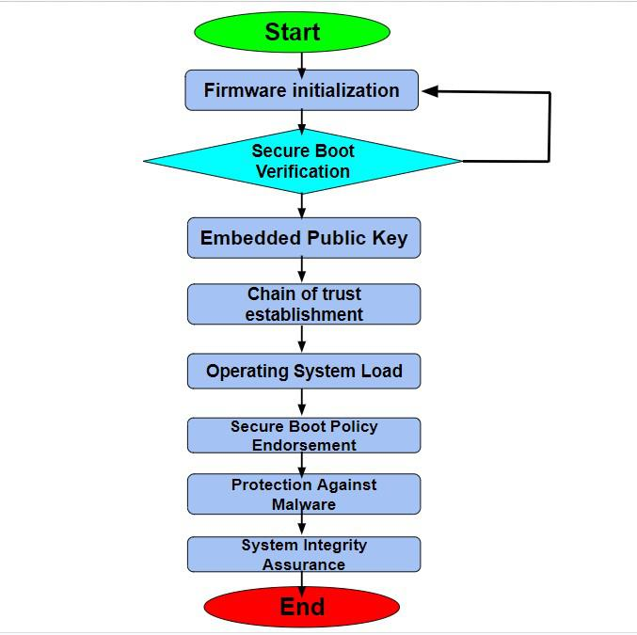
Figure 2: Secure Boot Verification Flow.

4. Firmware Authentication Mechanism
Firmware images are digitally signed by an authorized entity. MCUboot verifies firmware signatures and SHA-256 hashes to ensure authenticity and integrity.

5. Dual-Slot Firmware Layout
A dual-slot firmware layout is used where the primary slot contains the active firmware and the secondary slot stores the update firmware.

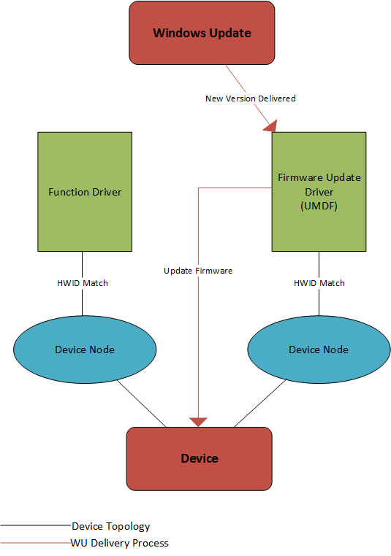

Figure 3: Dual-Slot Firmware Layout

6. Rollback Protection
Rollback protection prevents installation of older or vulnerable firmware versions by enforcing monotonic firmware version control.

7. Firmware Update Verification Flow
Firmware updates are securely downloaded, verified before installation, verified again after reboot, and rolled back automatically if validation fails.

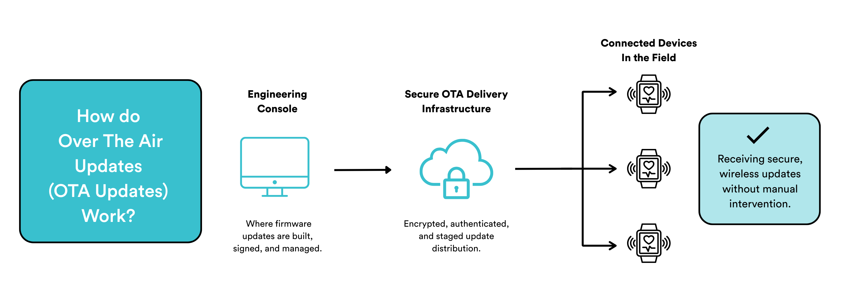
Figure 4: Firmware Update Verification Flow

8. Recovery and Fail-Safe Mechanism
If firmware corruption or update failure occurs, the system automatically restores the last known good firmware to ensure device availability.

9. Security Benefits Summary
This secure boot mechanism prevents unauthorized firmware execution, protects against tampering, ensures safe firmware updates and recovery, and establishes a strong root of trust.
Task 2: Code Signing & Cryptography

1. Digital Signing of Firmware
To ensure firmware authenticity, digital code signing is implemented using strong asymmetric cryptographic algorithms such as RSA (2048/4096) or Elliptic Curve Cryptography (ECC). Firmware images are signed using a private key by an authorized entity, while verification is performed using the corresponding public key stored on the IoT device.
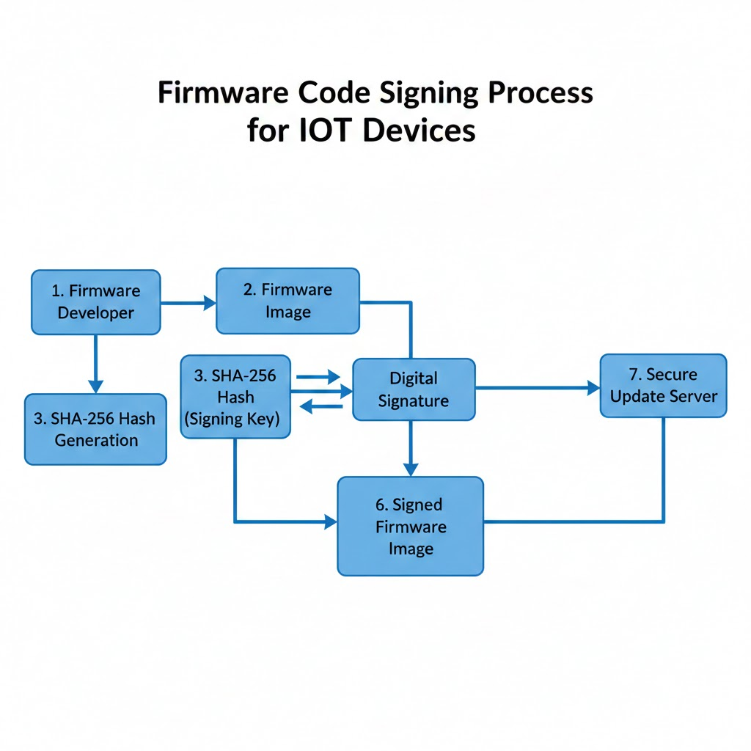
Reasons for using RSA / ECC:
- Provides strong authentication of firmware origin
- Prevents unauthorized firmware installation
- Industry-accepted cryptographic standards
- ECC offers smaller key sizes suitable for IoT devices

Figure 1: Firmware Code Signing Process

2. SHA-256 Hashing for Integrity Verification
SHA-256 hashing is used to ensure firmware integrity. A cryptographic hash of the firmware image is generated before signing. During verification, the firmware hash is recalculated and compared to detect any unauthorized modifications.

3. Secure Key Management Procedures
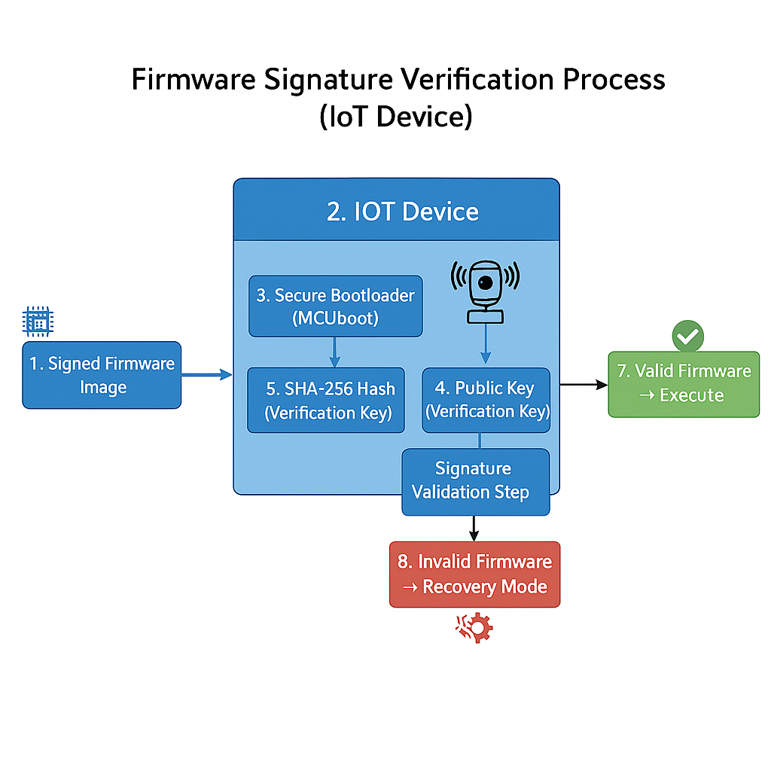
Secure key management is critical for maintaining trust in the firmware update mechanism.
Signing Keys (Private Keys):
- Used only for firmware signing
- Stored securely in a hardware security module or secure key vault
- Never stored on IoT devices
Verification Keys (Public Keys):
- Embedded into the secure bootloader during device provisioning
- Used only for signature verification

Figure 2: Firmware Signature Verification Using Public Key

4. Security Benefits Summary
The use of code signing and cryptography ensures firmware authenticity, detects tampering, prevents execution of unauthorized firmware, protects signing keys, and establishes a trusted firmware update pipeline.

Task 3: Firmware Update Verification

1. Overview
Firmware update verification ensures that only authentic, untampered, and authorized firmware is installed on IoT devices. Verification is performed both before and after installation to prevent malicious firmware execution.

2. Pre-Installation Firmware Verification
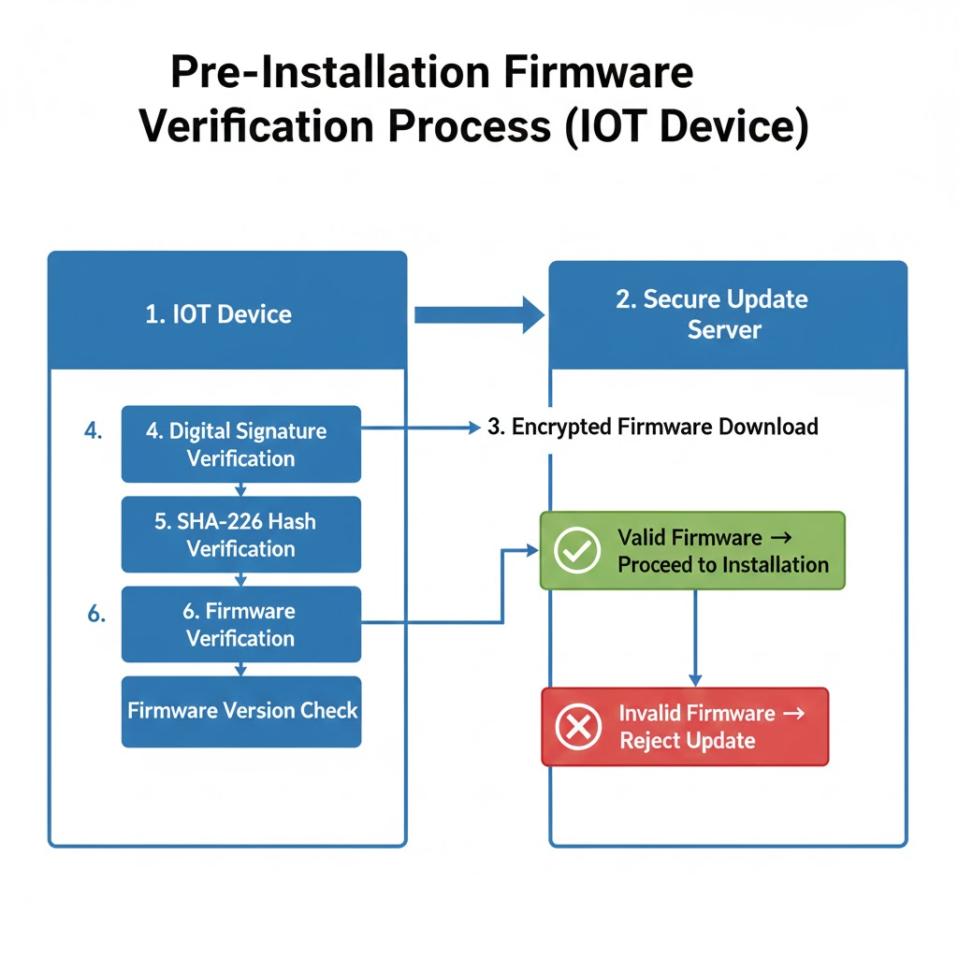
Before installing a firmware update, the device verifies the digital signature using the stored public key, recalculates the SHA-256 hash to ensure integrity, and checks the firmware version to prevent downgrade attacks.

Figure 1: Pre-Installation Firmware Verification Flow

3. Post-Installation Firmware Verification
After installation and reboot, the secure bootloader verifies the firmware signature and integrity before execution. If verification fails, the device does not continue execution.
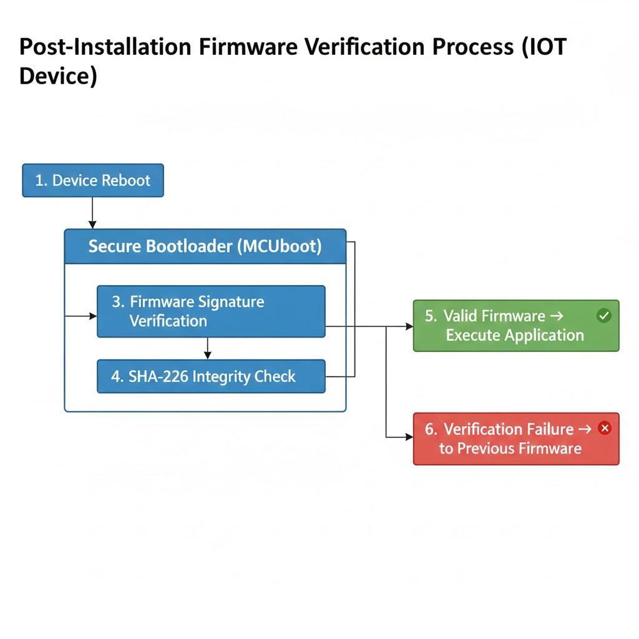

Figure 2: Post-Installation Firmware Verification Flo

4. Rollback Protection Mechanism
Rollback protection prevents the installation of older or vulnerable firmware versions by enforcing monotonic firmware version control.

5. Automatic Rollback and Recovery
If firmware installation or boot fails, the secure bootloader automatically restores the last known good firmware version, ensuring continued device operation.

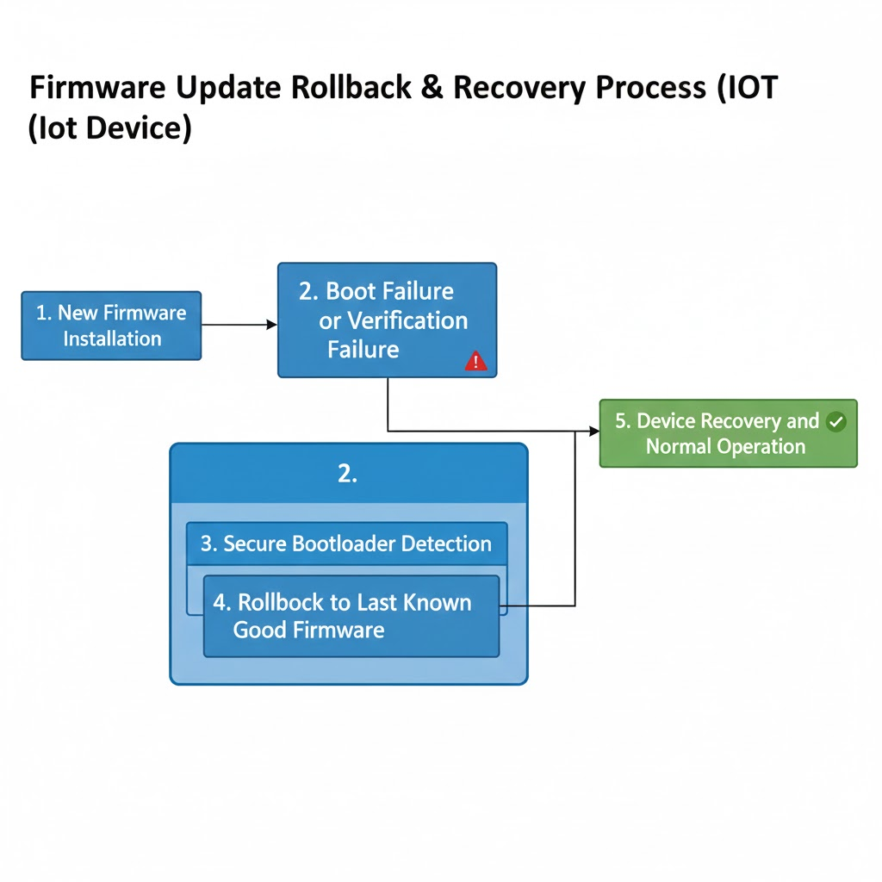

Figure 3: Rollback Protection and Recovery Mechanism

6. Security Benefits Summary
Firmware update verification prevents unauthorized firmware installation, detects tampering, protects against downgrade attacks, ensures device reliability, and strengthens overall IoT security.

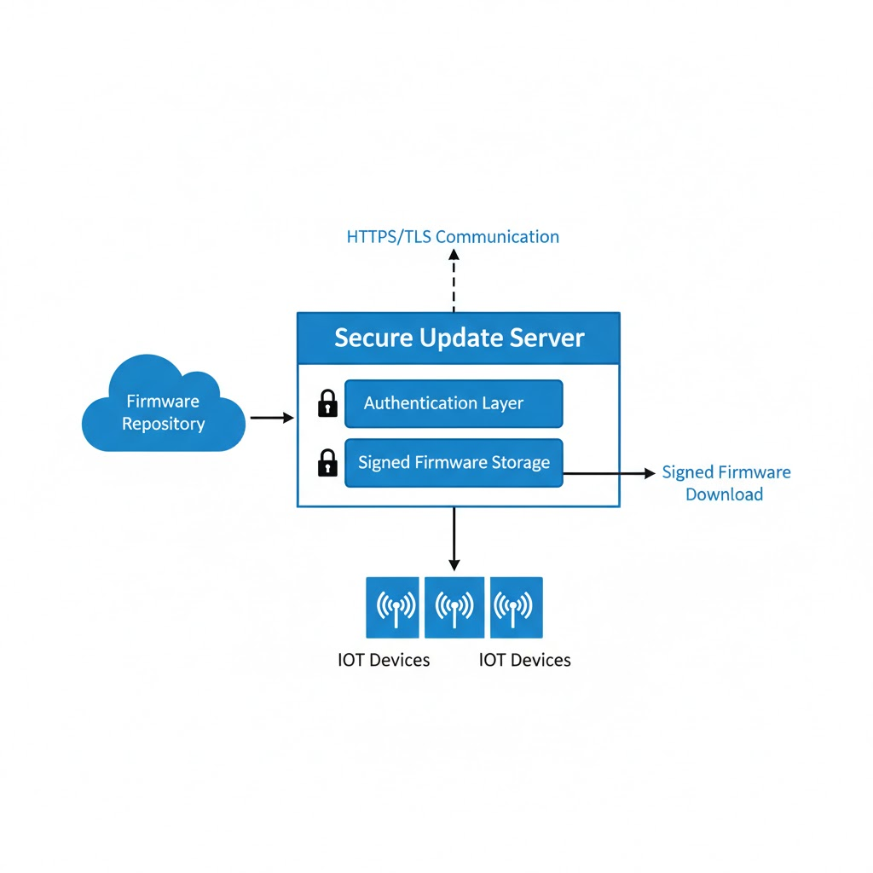
Task 4: Secure Update Server Setup

1. Secure Update Distribution Using HTTPS/TLS
The firmware update distribution server is deployed using secure communication protocols, specifically HTTPS with TLS encryption. TLS ensures confidentiality, integrity, and authentication of firmware data exchanged between IoT devices and the update server. This protects against man-in-the-middle attacks and unauthorized interception.

Figure 1: Secure Firmware Update Server Architecture

2. Delta Update Support for Bandwidth Optimization
To reduce bandwidth usage and improve update efficiency, the update server supports delta firmware updates. Instead of downloading the full firmware image, only the modified portions are transmitted. This approach reduces network usage and enables faster updates, especially for resource-constrained IoT devices.

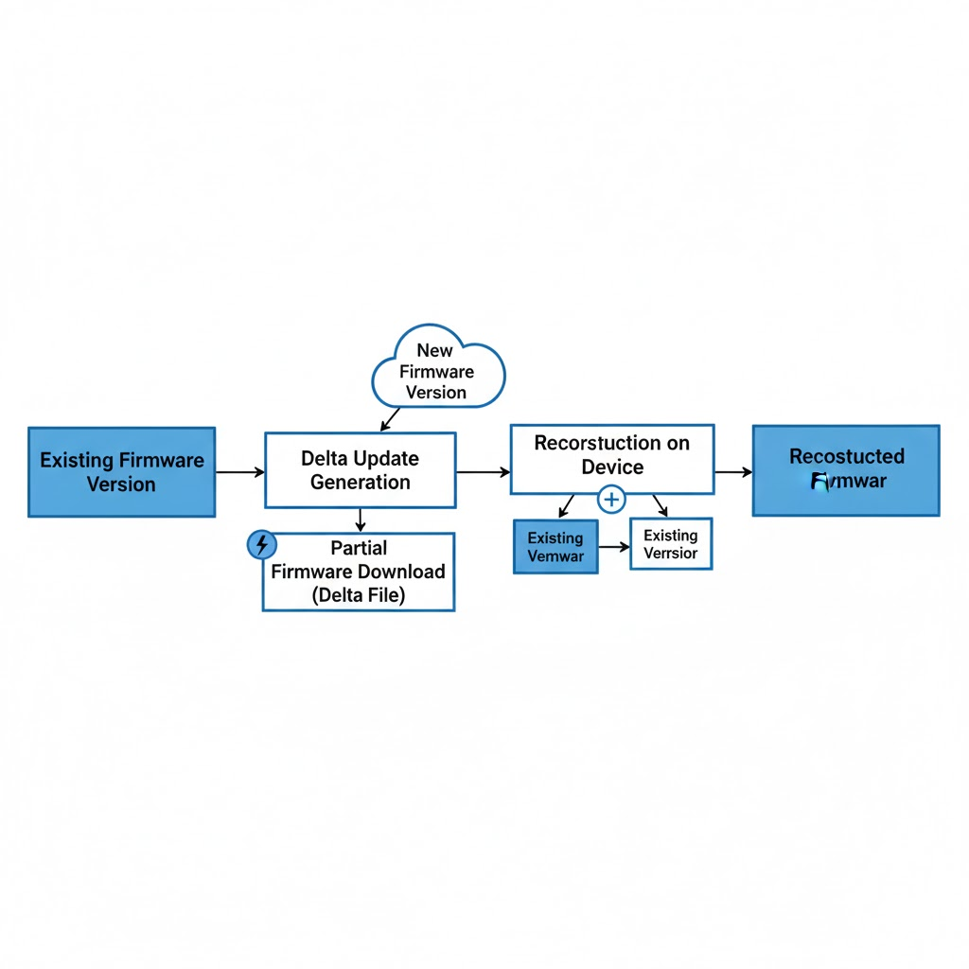

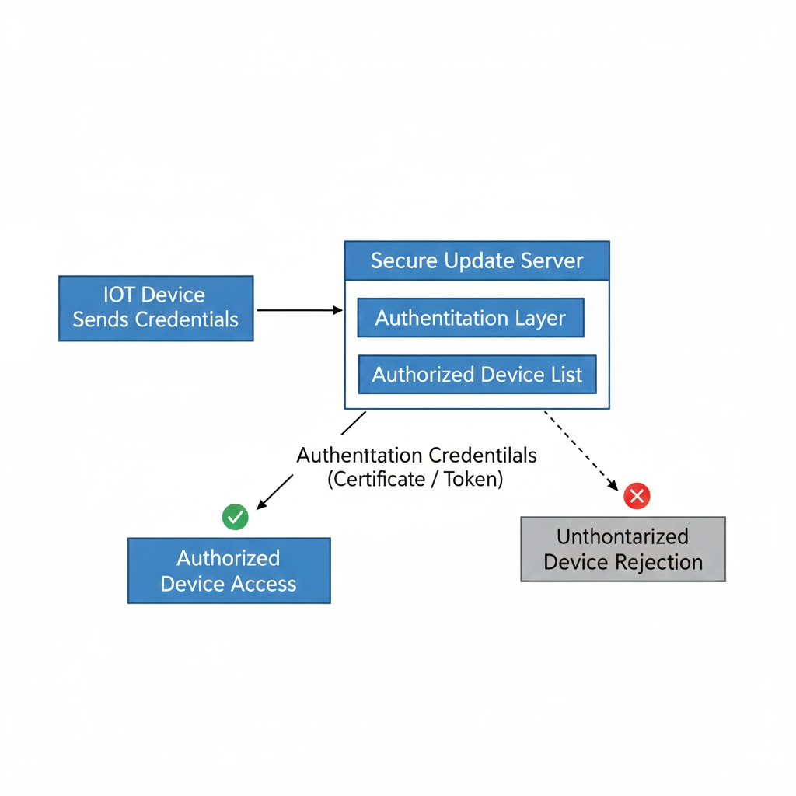
Figure 2: Delta Firmware Update Mechanism

3. Server Authentication and Device Authorization
The secure update server enforces authentication and authorization mechanisms to ensure that only trusted and registered IoT devices can request firmware updates. Authentication may be implemented using device credentials, digital certificates, or mutual TLS. Unauthorized devices are denied access to firmware resources.

Figure 3: Device Authentication with Secure Update Server

4. Security Benefits Summary
The secure update server setup ensures protected firmware delivery, prevents unauthorized access, optimizes bandwidth usage through delta updates, and strengthens the overall security of the IoT update system.

Task 5: User Authentication & Access Control

1. Overview
User authentication and access control ensure that only authorized users can manage firmware updates. This task focuses on role-based access control (RBAC) and audit logging mechanisms. No practical or hands-on implementation is included in this task.

2. Role-Based Access Control (RBAC)
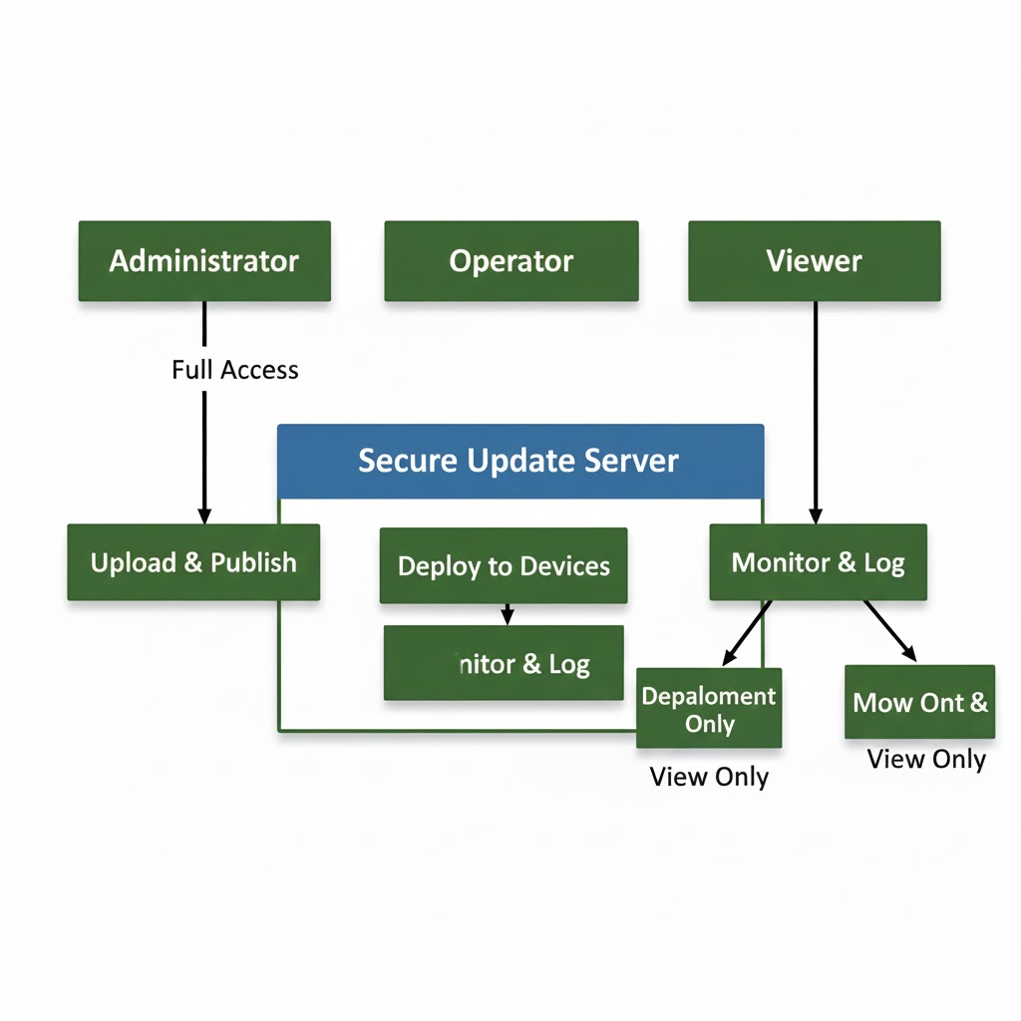
Role-Based Access Control (RBAC) restricts firmware update operations based on user roles.
Administrator:
- Manages users and roles
- Approves firmware updates
Operator:
- Uploads firmware images
- Schedules firmware updates
Viewer:
- Monitors update status
- Read-only access

Figure 1: Role-Based Access Control for Firmware Updates

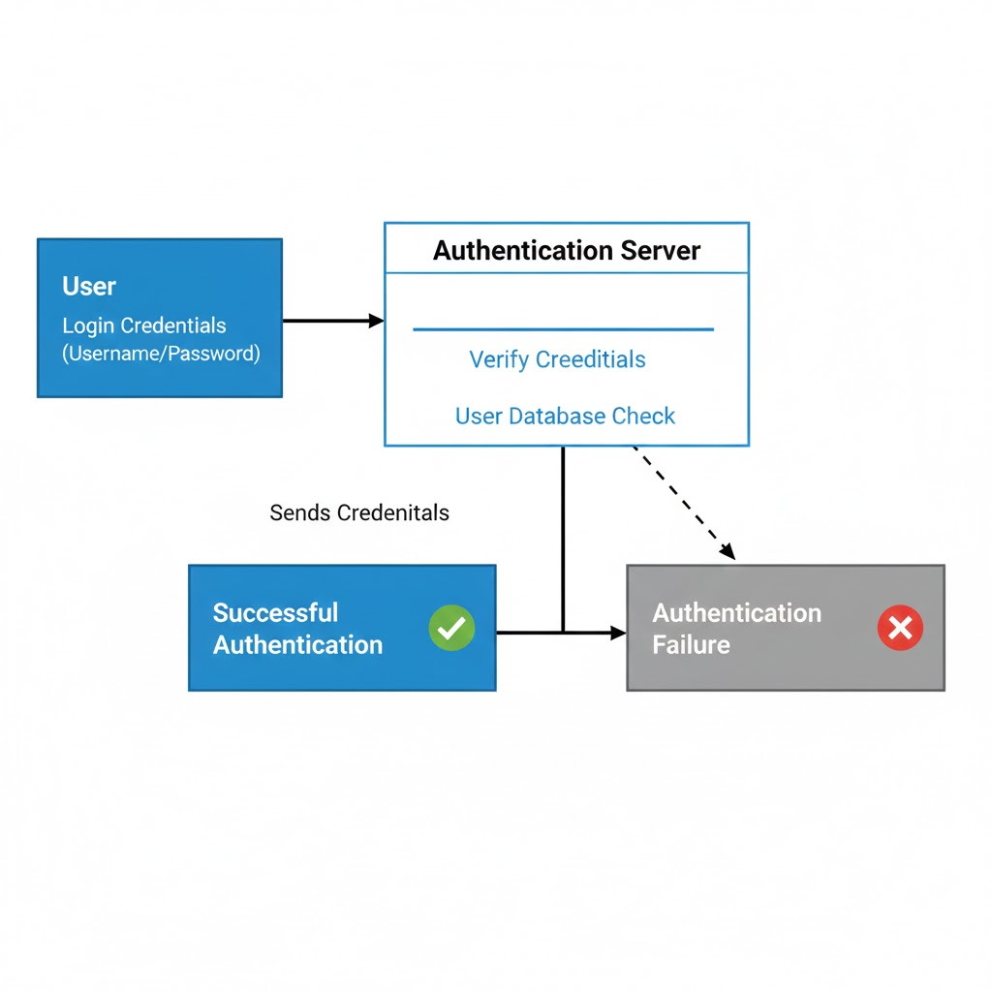
3.User Authentication Mechanisms
Authentication ensures that only legitimate users can access the firmware management system. Common authentication methods include username and password authentication, multi-factor authentication, and token-based authentication.

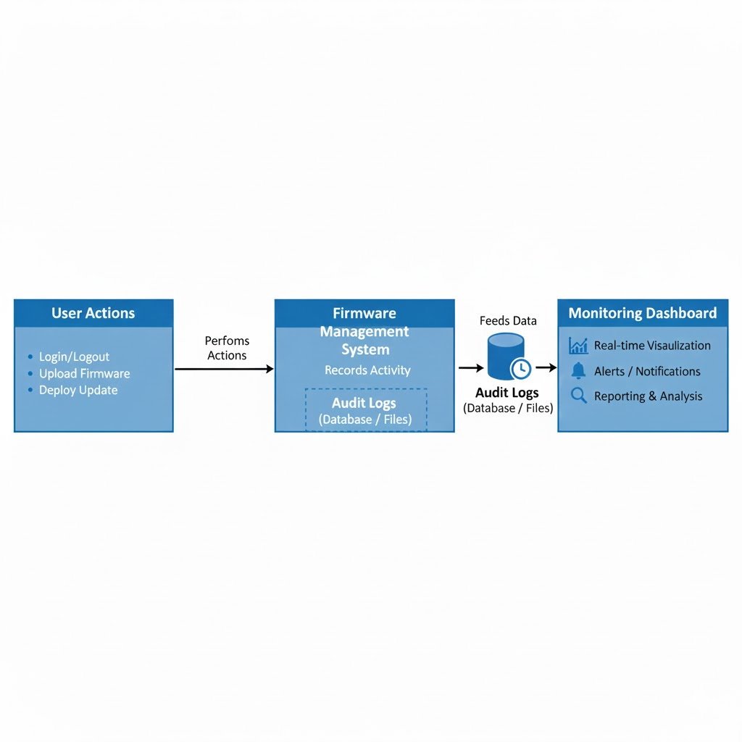

Figure 2: User Authentication Flow

4. Audit Logging and Monitoring
All firmware update-related activities are logged for auditing and monitoring purposes. Logged events include login attempts, firmware uploads, update approvals, and unauthorized access attempts.

Figure 3: Audit Logging and Monitoring Flow

5.Security Benefits Summary
User authentication and access control prevent unauthorized firmware updates, enforce accountability through role separation, and support compliance and security auditing.

Implementation Note
This task is completed at a theoretical level only. No practical or hands-on implementation is included.

Task 6: Usability & Management Features

1. Overview
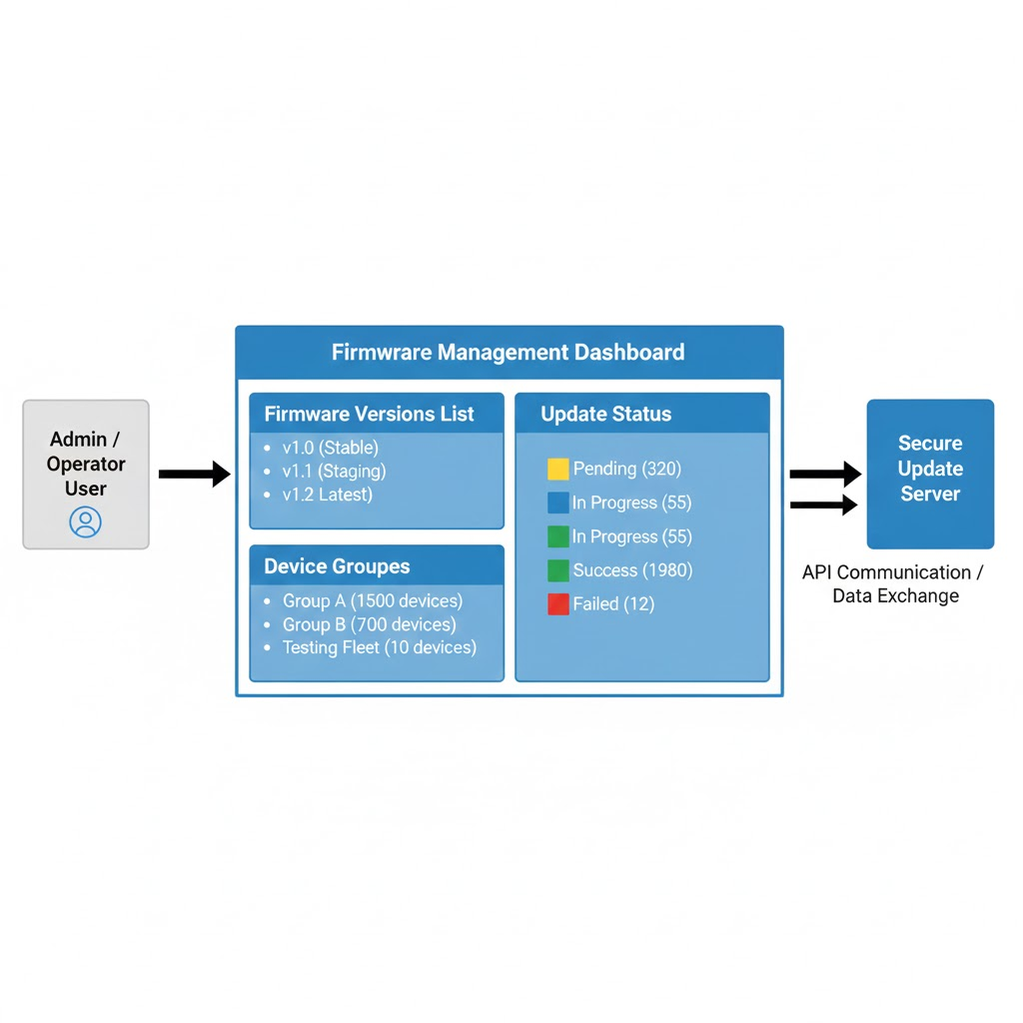
Usability and management features ensure that firmware updates can be easily scheduled, monitored, and controlled by authorized users. This task focuses on update management interfaces, automation, manual controls, and notification mechanisms. No practical or hands-on implementation is included in this task.

2. Firmware Update Management Interface
A centralized firmware management interface is used to manage firmware updates. This interface may be implemented as a web-based dashboard or a command-line interface (CLI). It allows administrators to manage firmware versions, initiate updates, and monitor progress.

Figure 1: Firmware Update Management Dashboard

3. Automated Update Scheduling
The system supports automated firmware update scheduling to reduce manual effort. Updates can be scheduled during off-peak hours or within predefined maintenance windows, ensuring minimal service disruption.

4. Manual Update Control and Overrides
Manual update controls allow administrators to initiate, pause, or cancel firmware updates. This is useful for emergency patch deployment or controlled rollout scenarios.

5. User Notifications and Status Reporting
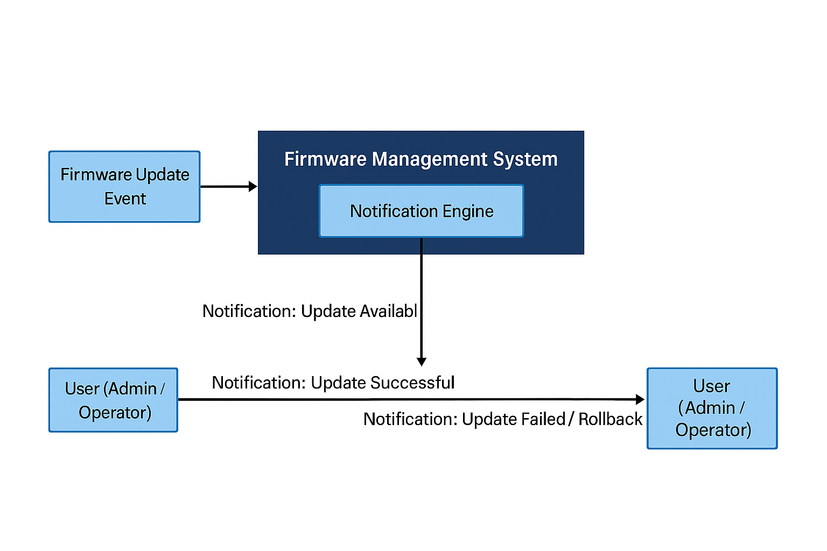
The system provides notifications to inform users about firmware update activities. Notifications include update availability, successful installations, and failure or rollback alerts.
Figure 2: Firmware Update Notification Flow

6. Monitoring and Reporting Features
Monitoring and reporting features provide visibility into update operations. They include real-time status monitoring, update success and failure reports, and historical update records.

7. Security Benefits Summary
Usability and management features simplify firmware update operations, reduce human error, improve visibility, and ensure timely deployment of security updates.

7. Testing and Failure Recovery

1. Overview
Testing and failure recovery features ensure that the secure firmware update system remains reliable and resilient under fault conditions. This task focuses on validating secure boot behavior, firmware update verification, and recovery mechanisms during update failures. The objective is to confirm that the system prevents execution of unauthorized firmware and maintains device availability. No practical or hands-on implementation is included in this task.

2.Secure Boot Validation Testing
Secure boot validation testing is performed to verify that only authenticated firmware is allowed to execute on the device. The system is tested using both valid and tampered firmware images.
Valid firmware testing ensures that firmware signed with an authorized key is accepted and executed successfully during boot. Tampered firmware testing involves modifying the firmware image after signing, which results in signature verification failure and rejection by the bootloader.
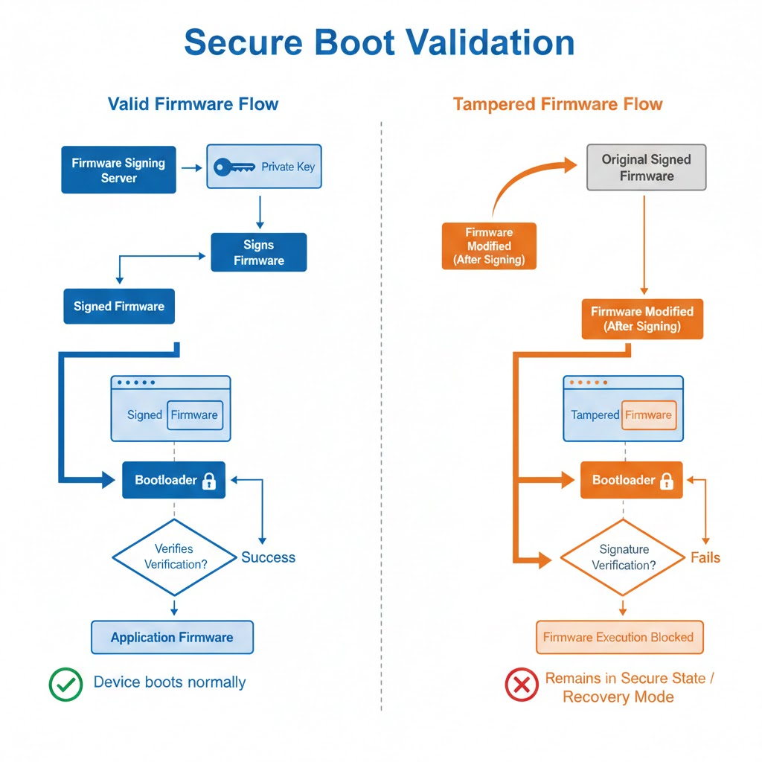

Figure 1: Secure Boot Validation with Valid and Tampered Firmware

3. Firmware Update Verification Testing
Firmware update verification testing ensures the integrity and authenticity of firmware updates before installation. The system validates firmware images by detecting corrupted and unauthorized updates.
Corrupted firmware updates are simulated by altering the firmware image during storage or transmission, causing integrity verification failure. Unauthorized firmware updates are simulated by signing firmware with an untrusted key, leading to signature verification failure and update rejection.
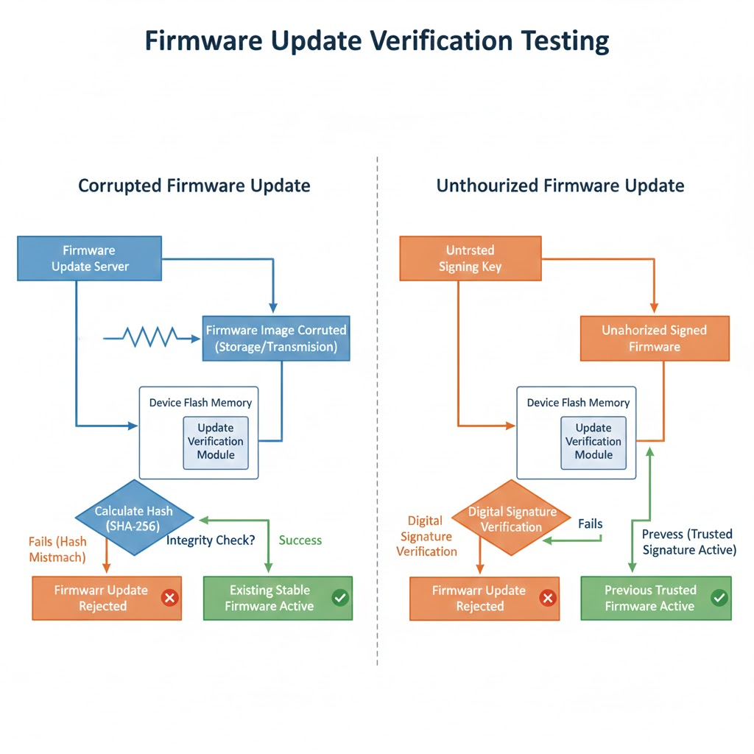

Figure 2: Firmware Update Verification Flow for Corrupted and Unauthorized Firmware

4. Failure Scenario Handling
Failure scenarios are analyzed to evaluate system behavior during abnormal update conditions. These scenarios include power interruption during firmware installation, incomplete firmware downloads, and verification failures after update completion.
In such cases, the system prevents activation of the faulty firmware and continues operating with the previously installed stable firmware, ensuring uninterrupted device functionality.

5. Firmware Recovery Mode
A firmware recovery mechanism is incorporated to restore normal operation after update failures. The recovery design typically uses a dual-slot firmware architecture, consisting of an active firmware slot and a backup slot.
If the newly updated firmware fails validation or booting, the system automatically reverts to the last known good firmware version. This rollback mechanism prevents permanent device failure and supports system reliability.
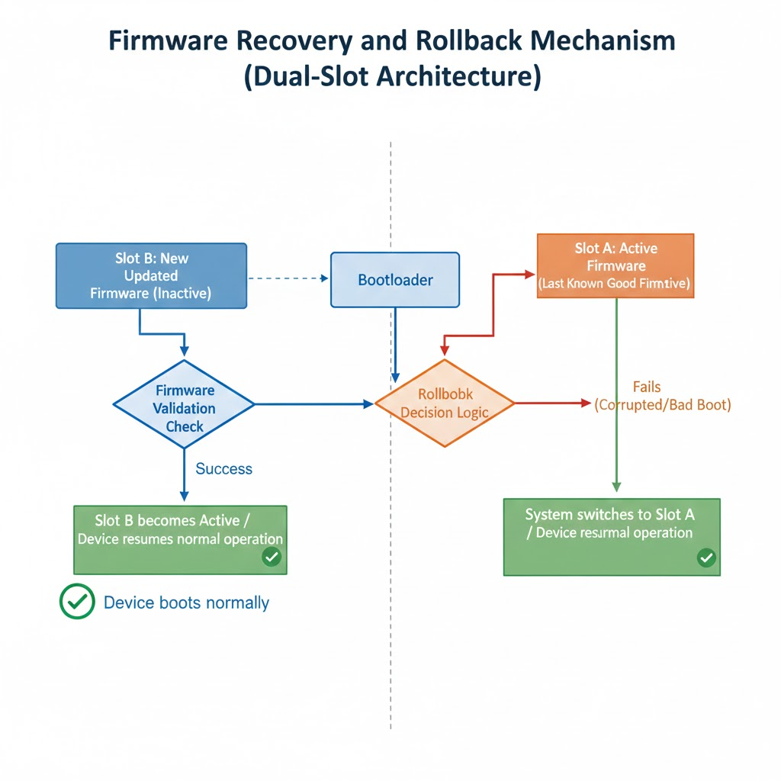

Figure 3: Firmware Recovery and Rollback Mechanism

5. Security Benefits Summary
Testing and failure recovery features strengthen system reliability by preventing execution of unauthorized firmware, protecting against corrupted updates, and ensuring recovery from failed update scenarios. These mechanisms enhance system stability, availability, and long-term security.

8. Compliance and Standards Alignment

1.Overview
Compliance and standards alignment ensure that the secure firmware update solution follows recognized cybersecurity best practices and regulatory requirements. This task focuses on mapping the proposed solution to established IoT security standards and preparing compliance checklists for applicable data protection and privacy regulations. No practical or hands-on implementation is included in this task.

2. Alignment with NIST IoT Cybersecurity Guidelines
The solution is aligned with the NIST IoT Cybersecurity Framework, which emphasizes device identification, protection, detection, response, and recovery.
Key alignments include:
- Secure boot and firmware authentication to ensure device integrity
- Cryptographic verification of firmware updates to prevent unauthorized code execution
- Logging and monitoring mechanisms to support threat detection
- Rollback and recovery mechanisms to support system resilience and recovery
These measures support NIST recommendations for securing the IoT device lifecycle.

3. Alignment with IoT Security Foundation Recommendations
The solution follows IoT Security Foundation best practices related to secure device updates and lifecycle security.
Key recommendations addressed include:
- Acceptance of only authenticated and integrity-verified firmware updates
- Secure key management and protection of trust anchors
- Protection against firmware tampering and rollback attacks
- Resilience against update failures through recovery mechanisms

4. Regulatory Compliance Considerations
To address regulatory and privacy requirements, compliance checklists are prepared for relevant regulations.
GDPR (General Data Protection Regulation):
- Secure handling of device and user-related data
- Protection of firmware update logs and identifiers
- Support for accountability through logging and audit trails
HIPAA (Health Insurance Portability and Accountability Act):
- Ensures integrity and security of firmware in healthcare-related devices
- Prevents unauthorized firmware modifications affecting patient safety
- Supports availability and recovery requirements

5. Compliance Checklist Preparation
Compliance checklists are used to verify that implemented security controls meet standard and regulatory requirements.
Checklist items include:
- Secure boot enforcement enabled
- Firmware integrity and signature verification implemented
- Access control and authorization mechanisms defined
- Logging, monitoring, and audit support available
- Recovery and rollback mechanisms tested

6.Security Benefits Summary
Standards and compliance alignment improves system credibility, reduces regulatory risk, and ensures adherence to recognized security best practices. Mapping the solution to established frameworks supports secure deployment, maintenance, and long-term operation of IoT devices.

